**Emotion Classification Report and Insights**

**1. Data Loading and Overview**

The code loads the dataset using Pandas and creates a copy for manipulation.

Exploratory Data Analysis (EDA) is performed, generating word clouds for different emotions to visually represent frequent words associated with each emotion.

**Insights:**

The dataset is successfully loaded, and EDA provides a qualitative understanding of the textual data.

**2. Text Preprocessing**

A preprocessing function is defined to handle lowercase conversion, HTML tag removal, URL handling, unwanted character removal, tokenization, and lemmatization.

The dataset is split into training and testing sets.

A pipeline (Pipeline) is created to handle preprocessing, vectorization using CountVectorizer, and classification using Multinomial Naive Bayes.

**Insights:**

Text preprocessing is a crucial step, ensuring clean and meaningful input for the machine learning model.

The pipeline encapsulates the entire process, enhancing code modularity and readability.

**3. Model Training**

The model is trained on the preprocessed training data using the defined pipeline.

The trained model is saved using the pickle module for future use.

**Insights:**

Multinomial Naive Bayes is chosen as the classification algorithm, suitable for text classification tasks.

Saving the model allows for quick and easy deployment in other applications.

**4. Streamlit App Integration**

The Streamlit app is implemented to allow users to input text and receive real-time emotion predictions using the trained model.

**Insights:**

Streamlit provides an interactive and user-friendly interface for model deployment.

Real-time predictions enhance the usability of the emotion classification model.

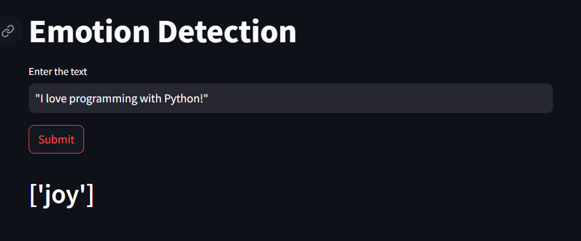

**5.Conclusion**

The Emotion Detection project aimed to develop a machine learning model capable of classifying emotions in text data.

The completion of this project not only demonstrates proficiency in natural language processing and machine learning but also provides a foundation for future developments in emotion detection applications